August 21, 2020

EXTENSION OF AWARD POSTING DATE

THE DATE FOR POSTING THIS AWARD HAS BEEN EXTENDED TO
AUGUST 24, 2020 PENDING FURTHER EVALUATION.

REFERENCED FPB NUMBER: USC-FPB-3639-AS

FOR: Provide Strategic Planning Consulting Services

ISSUE DATE: June 23, 2020

DEADLINE FOR RESPONSES: August 4, 2020

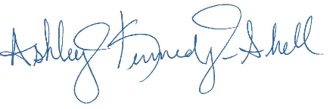

Ashley Kennedy-Shell
Buyer

